Jhargram Raj College
English Department
NOTICE

ENG/N-11 09.05.2022
This is to notify Students of Semesters II, IV and VI that Internal Assessment,2022 will be held on 11.05.2022 from 12 Noon.

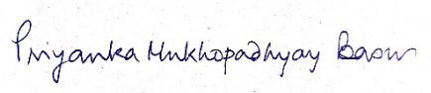
Head
Department of English

